**Practice Photography Brief**

**1. ABOUT <INSERT PRACTICE NAME>***<Insert your own ABOUT here. Focus on your brand personality that you wish to be captured, a bit about your people, your services, and your patients, local area and what is unique about you. The more of a personal story you share, the more authentically the photographer can capture who you are as a business.>*

**2. PHOTOGRAPHY USAGE AND SPECS  
Digital.** This photography will be used primarily for web (on our own practice website, and on **provision.com.au** in our dedicated practice page). They will shape the consumer’s first impression of our practice and staff, and will be a key influencer of whether or not the browser chooses to book an appointment with us.

**Print.** We may also use the photos in print collateral therefore we require the shots to be taken in the highest quality possible.

**Specs.** Please take photos with the following specs in mind: min. 2000 wide and 500 high, high resolution (for website banner). Other images may be used for in the following format: min. 800 wide and 600 high.

**3. DELIVERABLES - HERO IMAGES**The objective is to create an emotional connection by candidly capturing the practice and staff in warm, friendly photography that portrays their unique personalities and the **personal care that is part and parcel of the independent optometry experience.** The photography should invoke feelings of trust and expertise, as well as the local, individual flavour of the practice.

**Hero Images**

* Shop front photo
* Wide shot of interior of practice
* Street view photo
* Team photo
* Individual headshots
* Candid photos of optometrist in consultation (eye test) with “patient”
* Candid photos of “patient” interacting with staff at reception
* Candid photos of “patient” choosing glasses and being fitted for eyewear
* Other candid photos relevant for the specific practice that reflect aspects of their services e.g. “patient” having retinal photography scan (featuring their technology), kids’ vision, kids’ area, contact lenses, etc.

The optometrists and staff looking friendly and inviting. Movement and unposed photography is ideal, and either stand in or real patients to help convey the personalised experience.

**Headshots**Headshots of each optometrist (must allow for image to be displayed in a circle)

**4. SAMPLE PHOTOGRAPHY – A STYLE GUIDE**

Please see below sample photography as a guide of the quality and style we are looking for (continued on next page).

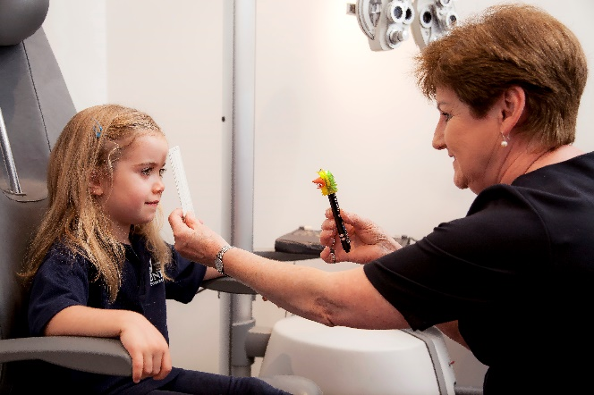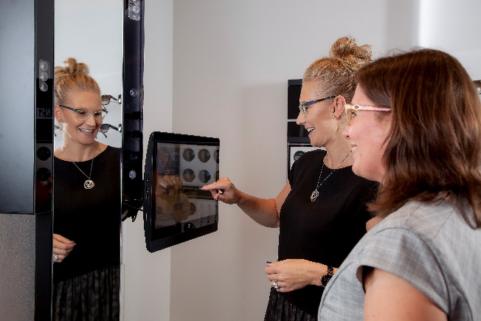

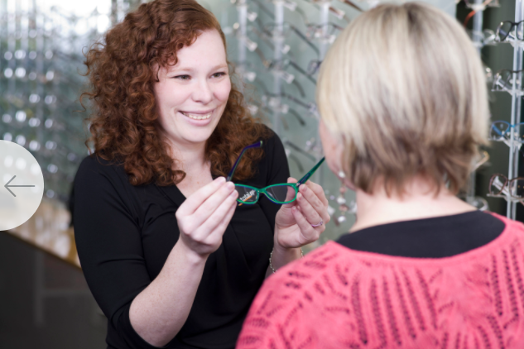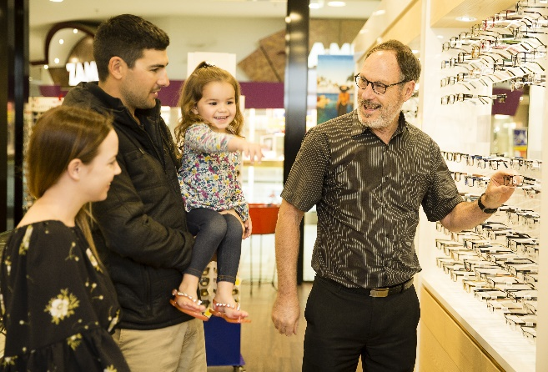

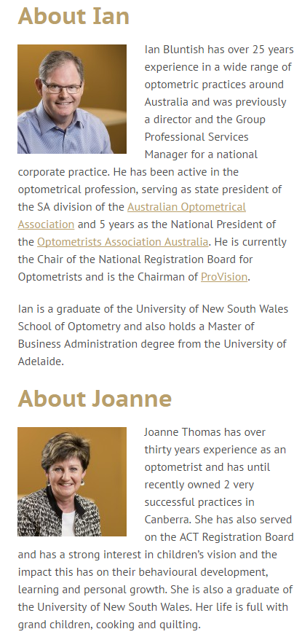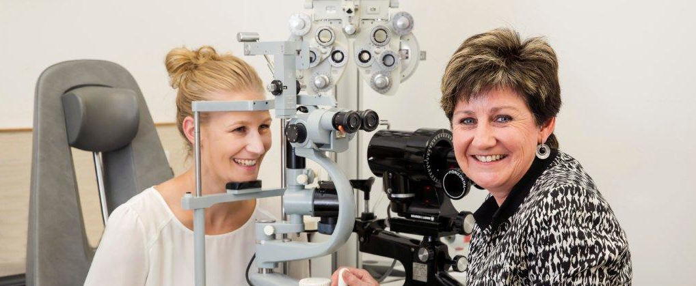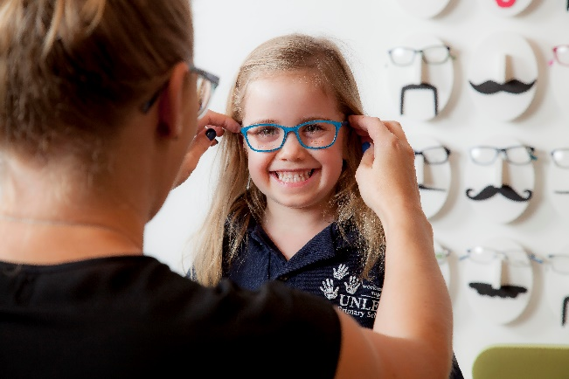

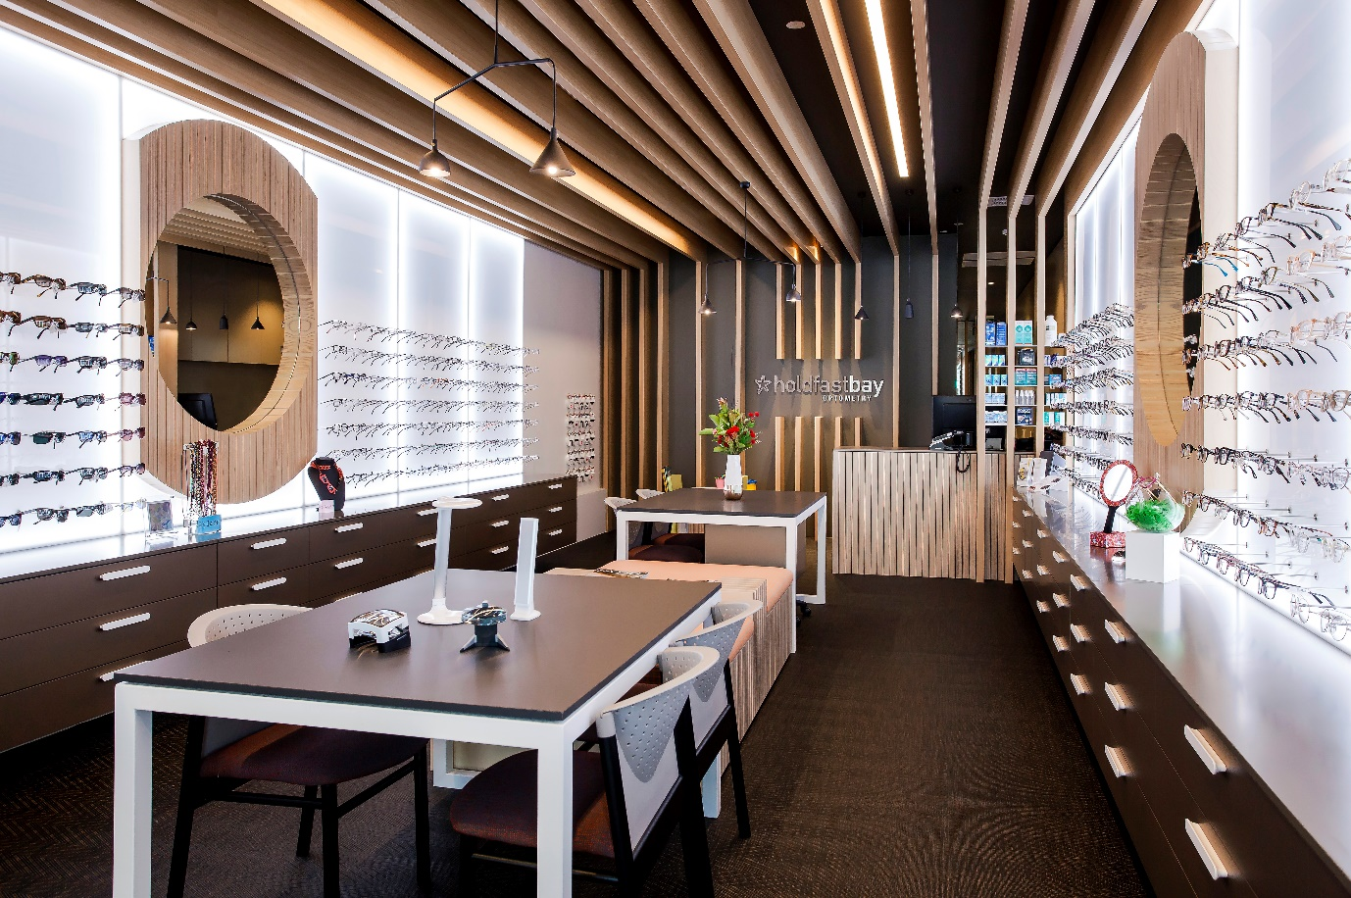

**5. PHOTOGRAPHY PRODUCTION/FILES**  
- Retouch and provide hi-res working files  
- Also provide original hi-res raw images

**6. CLOTHING**

Please provide advice in relation to which colour clothing would work well for the shoot.