ARA “How To” create a policy

Step 1 Login Page
Enter Username and Password
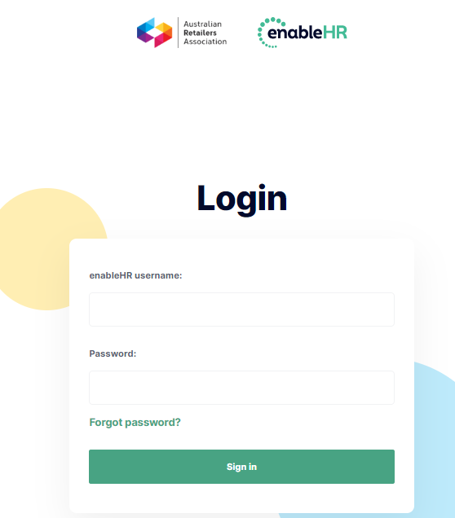

Landing Page (or similar)
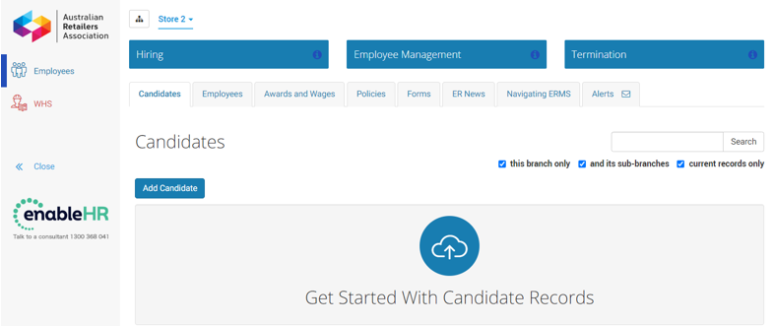

Step 2. Select Policies (located under employee management)
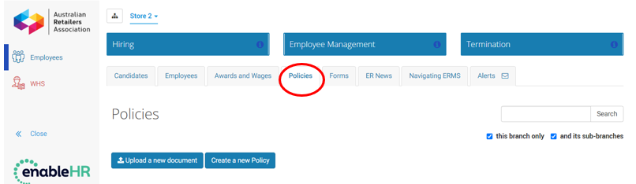

Step 3. Select “Create a new Policy”
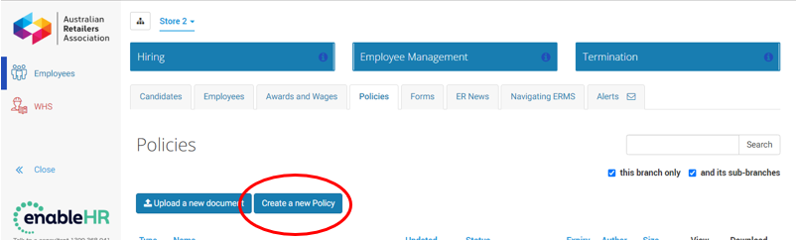
Step 4. Select the type of template you want to create from the drop-down box and then press “Next”
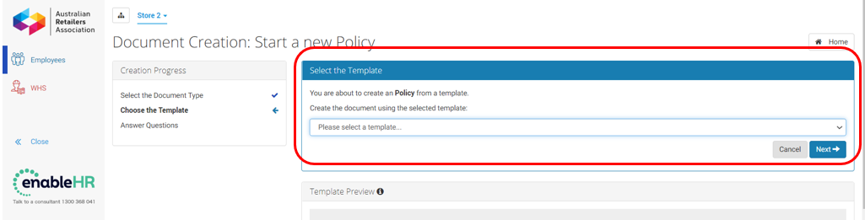

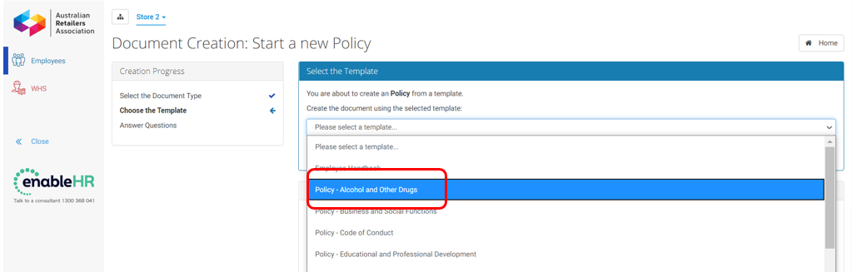

Step 5. Respond to each question
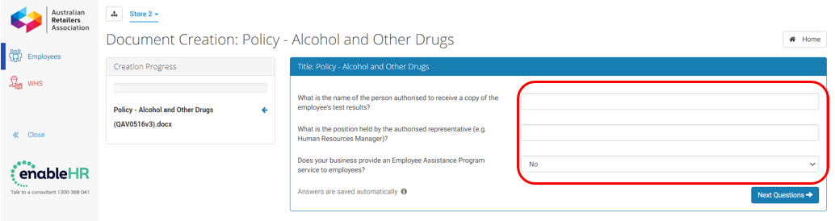

When you have answered all the questions you will taken to the finalisation screen
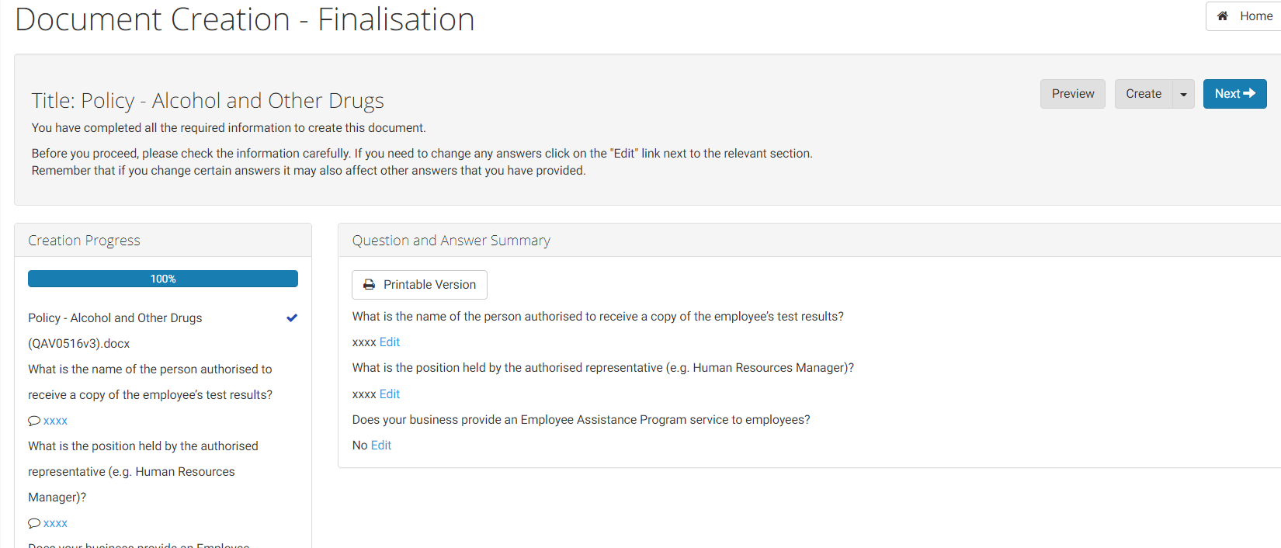

You will then able to “create” either a Word or PDF document.
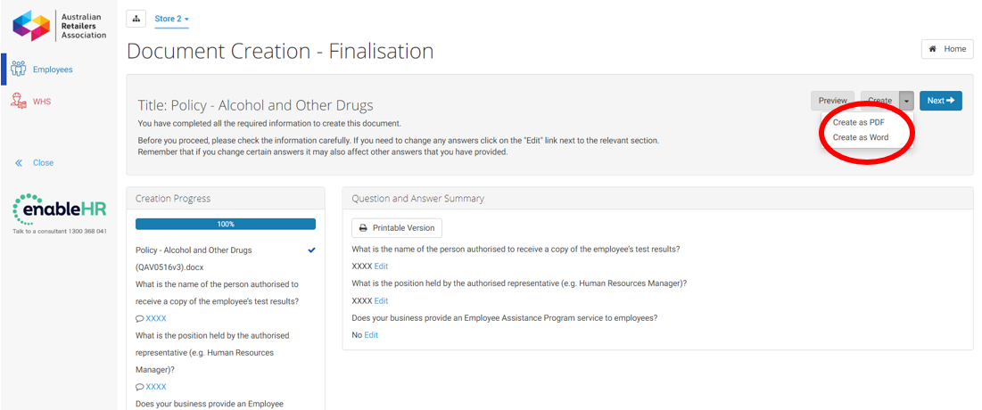

Select one of the options below to finalise the policy
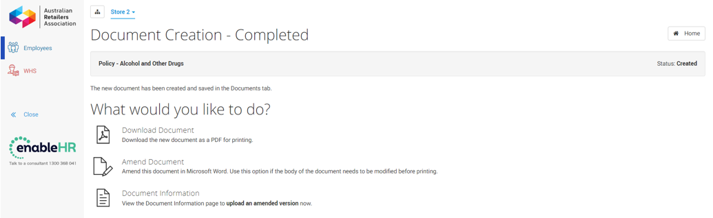

Congratulations! You have now successfully created a new policy.

If you need any assistance with the ERMS or updating your employment policies, please do not hesitate to contact ARA Employment Relations team on 1300 368 041 or email support@enablehe.com or contact your ProVision Business Coach

